Zepto – A Case Study on Inventory Management

Company Background
India’s fastest growing e-grocery company, Zepto, was founded in 2021 by two Stanford University dropouts out of necessity during COVID-19 pandemic. It currently stands at $1.4 billion USD following its recent fundraising. With a major presence in over 10+ cities, they focus on fast and efficient delivery of over 5000 products including food, daily essentials, health, hygiene, etc. They are known for their purpose - delivering to customers’ doorsteps in under 10 minutes.
The company operates in highly competitive environment where product availability, speed and customer service is essential to their success. Because of the quick-commerce business model, stockouts directly impact revenue, customer trust and platform reliability. Hence, maintaining optimal inventory levels across the country are essential and a key operational challenge for Zepto.

Learning Context & Data Framing
The motivation for this project stemmed from an in-class simulation exercise based on the Transentis Beer Game, where participants assumed the role of a retailer (or other supply chain managerial roles) responsible for managing inventory, placing replenishment orders, and responding to fluctuating demand.
During the simulation, small delays in ordering decisions and limited visibility into upstream supply quickly led to stockouts or excess inventory, highlighting how uncertainty, lead times, and behavioral decisions can significantly impact inventory performance. Experiencing these dynamics firsthand sparked an interest in understanding how real-world companies, especially in different sectors, manage stockout risk and inventory prioritization using data rather than intuition alone.
This project builds on those insights by applying data-driven analysis to a real retail context, focusing on how inventory availability signals can be used to support better replenishment decisions in fast-paced operational environments.
Through this project, I aim to develop my skills whilst understanding and gaining a deeper insight into the supply chain/logistics aspects of inventory management on an analytical scale.

Data Overview
This analysis uses a publicly available dataset, from Kaggle, which contains product-level information across multiple grocery categories. Each record represents a SKU with attributes related to pricing, discounts, package size, and inventory availability.
Key fields in the dataset include:
- Product category and name
- Maximum retail price (MRP) and discounted selling price
- Discount percentage
- Available quantity
- Out-of-stock indicator (binary flag)
- Product weight and unit quantity
The dataset provides a snapshot of current inventory availability, rather than historical sales or demand data.

Business Problem
Despite having visibility in current inventory levels, quick-commerce platforms often lack complete demand information at the SKU (Stock Keeping Unit) level in real time. As a result, inventory decisions must be made under uncertainty, using proxy indicators such as pricing, discounting, and stock availability.
The key operational challenge addressed in this project is:
How can Zepto identify high-risk stockouts and prioritize inventory replenishment across products and categories when demand data is limited?

Project Objective
The objective of this project is to analyze Zepto’s product-level inventory data to:
- Identify categories and products with the highest stockout risk
- Estimate potential revenue exposure due to out-of-stock items
- Develop an inventory prioritization framework to support replenishment decisions
The final outcome is a data-driven prioritization approach that can help operations teams focus replenishment efforts where the business impact is highest.

Executive Summary
Zepto, India's fastest-growing quick-commerce platform, currently has 453 out-of-stock SKUs across its product catalog, representing a total estimated revenue exposure of ₹39,018. This project analyzes 3,729 SKU-level records across 14 product categories to address a core operational challenge: how should replenishment decisions be prioritized when demand data is limited?
The analysis reveals a critical insight: stockout rate alone is a misleading signal for inventory prioritization. Biscuits, the category with the highest stockout rate at 28.6%, ranks near the bottom for revenue impact at just ₹1,650. Meanwhile Cooking Essentials and Munchies, both with average stockout rates of 12%, each contribute ₹5,830 in revenue exposure which is the highest of any category. This divergence is explained entirely by price point differences across categories.
In order to address this, I developed a composite SKU-level prioritization framework using three weighted business signals: out-of-stock status, normalized MRP, and category-level risk. The framework segments all 3,729 products into High, Medium, and Low replenishment priority tiers, giving operations teams a ranked, actionable list of exactly which products to restock first and why.

Problem Statement
Zepto's business model is built on a single promise - delivery in under 10 minutes. In quick commerce, a stockout is not just a missed sale. It is a broken promise to the customer, a potential churn event, and a direct signal to competitors like Blinkit and Swiggy Instamart that Zepto's reliability is slipping. On a scale, repeated stockouts in high-demand categories erode the customer trust that the entire platform depends on.
The operational challenge present here, is that with 3,700+ SKUs spanning everything from fresh produce to personal care, replenishment cannot happen simultaneously across all products. Supply chain teams must make triage decisions constantly, which products get restocked first, which warehouses get prioritized, and where to allocate limited logistics capacity.
Without a structured framework, these decisions tend to default to intuition or simple stockout counts, both of which can be misleading. A category like Biscuits may appear to be the biggest problem based on its 28.6% stockout rate, when in financial terms it is far less damaging than categories with lower stockout rates but higher price points.
The central question this project addresses is:
Given limited demand data and a large product catalog, how can Zepto identify which out-of-stock products represent the highest business risk and should be prioritized for immediate replenishment?

Data Overview
The dataset was sourced from Kaggle and contains 3,732 SKU-level records representing a snapshot of Zepto's product catalog across 14 categories. Each record contains 9 fields: product category, product name, maximum retail price (MRP), discounted selling price, discount percentage, available quantity, out-of-stock status (boolean), product weight in grams, and unit quantity.
Data cleaning summary: Prior to analysis, the following cleaning steps were performed:
- 2 exact duplicate rows were identified and removed
- 1 record with MRP of ₹0 (Cherry Blossom Liquid Shoe Polish) was removed as it represented a data entry error that would distort revenue calculations
- 0 missing values were found across all 9 columns (the dataset was otherwise complete)
- Discount consistency was validated by recalculating discount percentage from MRP and selling price for every row (0 mismatches were found, confirming pricing data integrity)
- MRP and discounted selling prices were converted from paise to rupees by dividing by 100 for readability and better understanding
Key dataset characteristics:
- Final working dataset: 3,729 SKUs across 14 categories
- Average MRP: ₹156.80, median ₹110 (right-skewed distribution indicating a few expensive products pulling the mean up)
- Total out-of-stock SKUs: 453, representing a platform-wide stockout rate of 12.1%
- Available quantity column appears capped at a maximum of 6 across all records, limiting its usefulness as a true stock level indicator (treated as a dataset limitation)

4. Methodology
1. Data Cleaning:
Initial profiling examined distributions, data types, missing values, duplicates, and logical consistency checks (selling price vs MRP, quantity vs OOS flag). Stockout rates were computed by category to establish baseline risk levels before any scoring was applied.
2. Revenue Exposure Calculation:
For each out-of-stock SKU, revenue exposure was calculated as its discounted selling price, representing the direct per-unit sale value that Zepto loses while the product remains unavailable. In-stock products were assigned an exposure of zero. This produced a revenue impact estimate at both the SKU and category level. Total platform revenue exposure: ₹39,018.50
3. Category Analysis:
Products were grouped by category and aggregated across five dimensions: total SKU count, out-of-stock SKU count, stockout rate, total revenue exposure, and average MRP. Categories were ranked by revenue exposure rather than stockout rate, which surfaced the key divergence between frequency-based and value-based risk.
4. Prioritization Framework:
A composite priority score was developed for every SKU using three signals:
- Weight 3: Out-of-Stock Flag
  - Heaviest weight – because being out of stock is the most direct and urgent signal. An OOS product contributes 3.0 to the score automatically. An in-stock would equal to 0. This ensures that every 00S product starts with a meaningful base score.
- Weight 2: Normalised MRP
  - MRP was normalised, again, to a 0-to-1 scare, using min-max normalization so that a ₹2,600 product scores 1.0 and the cheapest product scores 0. This was necessary as raw rupee values would dominate the score if added directly. This also recognizes that a high-value OOS product causes more financial damage than a cheap one.
- Weight 1: Category OOS Rate
  - Each SKU inherits its category’s overall stockout rate as a systematic risk signal. A product in Biscuits (28.6% OOS rate) scores higher on this dimension than a product in Fruits & Vegetables (6.5% OOS rate), reflecting that some categories are structurally more prone to stockouts. This signal received the lowest weight of 1 as it is an indirect, category-level measure rather than a product-specific one.
5. Threshold Selection and Tier Assignment
Products were assigned to three tiers: High, Medium, and Low, based on their priority score. The threshold between High and Medium was set at 3.3, and the threshold between Medium and Low was set at 1.0.
The reasoning behind 3.3 specifically: since the OOS flag alone contributes exactly 3.0 to the score, any OOS product has a minimum score of 3.0. The initial threshold was set at 3.5, which produced only 2 High-tier products, both of which were Patanjali Cow's Ghee, the single most expensive item in the dataset at ₹565. This threshold was visibly too restrictive because it was only capturing the most expensive outlier rather than identifying a meaningful high-risk segment.
Lowering the threshold to 3.3 means a product must be OOS and have a combined MRP and category risk contribution of at least 0.3 above the OOS baseline. This captures OOS products that are above average in either price or category risk, a more meaningful and operationally useful definition of "high priority" than simply being the most expensive item. The result was 60 High-tier products across the catalog, which represents a more realistic and actionable workload for an operations team.
The Medium threshold of 1.0 captures in-stock products in high-risk categories as a watch list, products that are not yet OOS but exist in categories with elevated stockout patterns and therefore warrant closer monitoring.

Key Findings
1. Stockout rate and revenue exposure tell different stories.
The most significant analytical finding of this project is that ranking categories by stockout rate produces a completely different priority order than ranking by revenue exposure. Biscuits leads on stockout rate at 28.6%, nearly double the platform average of 13.8%, but generates only ₹1,650 in revenue exposure, ranking near the bottom financially. This is because Biscuits have an average MRP of just ₹59, meaning even frequent stockouts cause limited financial damage per incident.
In contrast, Cooking Essentials and Munchies each have stockout rates of 12%, exactly at the platform average, but each generates ₹5,830 in revenue exposure, the highest of any category. Their average MRP of ₹156 means every OOS incident costs significantly more. A replenishment strategy based on stockout rate alone would direct resources toward Biscuits first and largely ignore Cooking Essentials - the opposite of what financial impact analysis recommends.
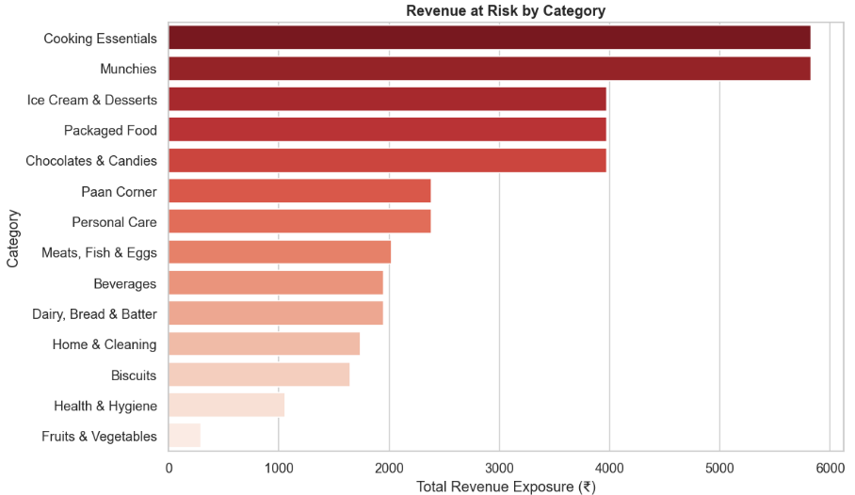
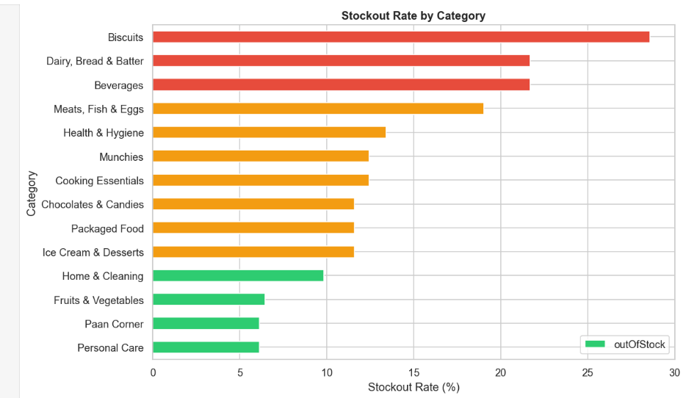
2. The problem is concentrated in a small share of SKUs.
Despite 453 total OOS SKUs, only 12.5% of the full catalog (approximately 466 products) falls into High or Medium priority tiers. The remaining 87.5% of SKUs are either in stock or represent low-value OOS items with minimal financial impact. This concentration means that a targeted intervention on a relatively small subset of the catalog can resolve the vast majority of Zepto's current revenue exposure. Operations teams do not need to treat this as a platform-wide crisis, they need a focused, prioritised list.
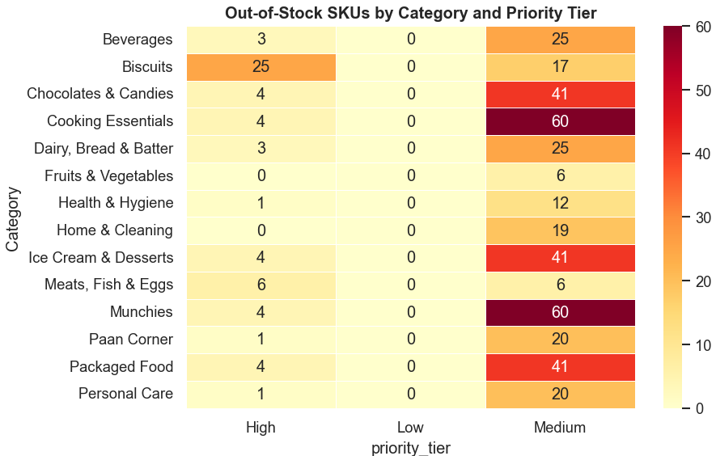
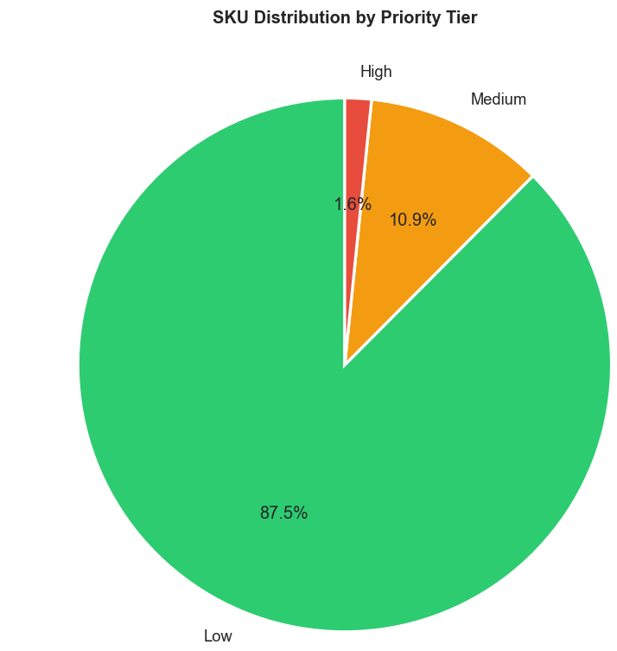
3. Stockouts are not discount-driven.
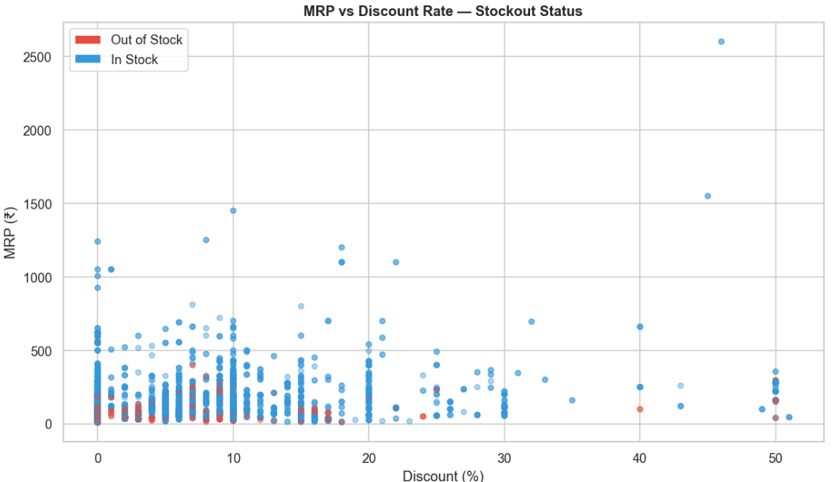
Scatter plot analysis of MRP versus discount percentage, colored by OOS status, shows that out-of-stock products are concentrated at low discount levels (0-10%). If stockouts were being caused by demand spikes driven by promotional discounts, OOS products would cluster at higher discount percentages. The absence of this pattern suggests stockouts are primarily a supply chain and replenishment lag issue rather than a demand forecasting failure. This distinction matters for the type of solution recommended, essentially the fix is better reorder triggers, not better demand prediction.
4. High-value products are better managed.
Almost no OOS products appear above ₹500 MRP in the scatter analysis. This suggests Zepto's operations teams are already, likely informally, prioritizing high-value items for stock maintenance. The prioritization framework built in this project formalizes and extends this implicit logic systematically across all price points, ensuring mid-range products between ₹100-₹400 receive appropriate attention relative to their financial contribution.
5. Biscuits require a different type of intervention
While Biscuits rank low on revenue exposure, its 28.6% stockout rate is a customer experience problem even if it is not a major financial one. Cheap and frequently purchased items like biscuits are the products customers expect to always be available. Repeated stockouts in this category may drive customers to competitor platforms for everyday purchases, creating long-term churn risk that does not show up in short-term revenue exposure calculations. This category warrants a separate operational response focused on safety stock levels rather than revenue weighted replenishment priority.

Recommendations
1. Prioritize replenishment by revenue exposure, not stockout rate.
Replace any existing stockout-count-based replenishment logic with the composite priority score framework developed in this project. The framework accounts for both the fact of being out of stock and the financial value of what is being lost, producing a ranked list that directs effort where it has the highest business impact. This is a low-cost operational change that requires only the maintenance of a regularly updated priority score table.
2. Immediate action on High tier SKUs.
The 60 High priority OOS SKUs, concentrated in Cooking Essentials and Munchies, should be treated as an immediate operational incident. These products combine out-of-stock status with above-average price points and exist in categories with elevated systemic risk. Replenishment orders for these specific SKUs should be escalated to supply chain teams within 24 hours of identification.
3. Set category-level stockout thresholds.
Biscuits (28.6%), Beverages (21.7%), and Dairy, Bread & Batter (21.7%) all show stockout rates significantly above the platform average of 13.8%. These categories have a structural tendency to run out of stock regardless of individual product price. Automated reorder points should be set at higher safety stock thresholds for all SKUs in these three categories, reducing the frequency of stockouts before they occur rather than reacting after the fact.
4. Enrich the dataset for better future decisions.
The 463 Medium-tier products include both OOS items with lower price points and in-stock products in high-risk categories. These should be surfaced in a daily monitoring view so that ops teams can spot products trending toward stockout before they cross the OOS threshold. A simple dashboard filtering on priority_tier = Medium, sorted by category_oos_rate, would serve this purpose.
5. Enrich the dataset for future iterations
The current prioritization framework uses only static snapshot data. Its accuracy would improve significantly with two additional data inputs: historical sales velocity per SKU (to weight frequently purchased cheap products more heavily) and lead time data per supplier (to adjust reorder timing based on how long restocking actually takes). Incorporating these signals would allow the priority score to reflect demand urgency, not just current price and availability status.
Limitations
- Static snapshot:
  - The dataset represents a single point-in-time view of inventory. Stockout patterns may vary significantly by time of day, day of week, or season. A time-series dataset would enable more robust pattern detection.
- No demand or sales data:
  - Revenue exposure is estimated using selling price as a proxy for lost revenue. Without actual order volume or sales velocity data, it is not possible to quantify how many units would have been sold. The true revenue impact may be higher or lower than the figures reported here.
- Available quantity limitation:
  - The available quantity field is capped at 6 across all in-stock records, making it impossible to distinguish between a product with 6 units remaining and one with 600. This column was excluded from the prioritization framework as a result.
- Duplicate SKU entries:
  - Multiple products appear under different row indices with identical attributes, suggesting the same SKU may be listed more than once in the source data. In a production system, a unique SKU identifier would eliminate this ambiguity.
- Prioritization threshold subjectivity:
  - The score thresholds of 3.3 and 1.0 were selected based on analytical reasoning and result distribution rather than validated business rules. In a real deployment, these thresholds should be calibrated against historical replenishment outcomes to confirm they identify the right products.

https://www.yourtribe.io/company/zepto/company-details
https://www.kaggle.com/datasets/palvinder2006/zepto-inventory-dataset?resource=download

